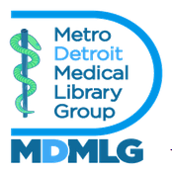

METROPOLITAN DETROIT MEDICAL LIBRARY GROUP (MDMLG)
Archivist 2025-2026 Goals & Objectives

Goals
- Donate inherited physical materials as well as 2024-2025 physical materials to Reuther Library.
- Create system for digital-born content and merge with physical collection.
- Gain knowledge about the processing of the MDMLG collection.

Objectives
- Work on a system for the deposit of digital-born archival materials with Steven Moore.
- Develop stronger relationship with Reuther staff and have a greater understanding of the processing process, and creation of finding aids.

